## PROJECT REPORT

UNEARTHING THE ENVIRONMENTAL IMPACT OF HUMAN ACTIVITY:A GLOBAL CO2 EMISSION ANALYSIS

**TDMNS COLLEGE**

**T.KALLIKULAM**

DEPARTMENT: PHYSICS

TEAM-4

K.PAVITHRA

R.RAXSANA

M.SUBHA LAKSHMI

P.PAVITHRA

UNEARTHING THE ENVIRONMENTAL IMPACT OF HUMAN ACTIVITY:

A GLOBAL CO2 EMISSION ANALYSIS

Introduction

Project description

Global warming is one of the biggest challenges currently being faced by the human race, although correlation is not causation, a likely cause of global warming is due to increased atmospheric carbon dioxide from human activities. **CO2 Emission** refers to the Carbon Dioxide emitted throughout the world. For this analysis we will be focusing on CO2 Emissions and its effect on the world we live in as well as some key factors and stats that may play a role in the emission of CO2 globally. Fossil fuel use is the primary source of CO2. The data throws light onto how much fossil fuels are burnt, per year per nation, which amounts to an increase in CO2 every year. This will help researchers and environment experts to predict global warming. So countries should set a goal to decrease this amount yearly.

Analysing Global Co2 Emission across countries from 1975 to 2020. This dataset contains a record of Co2 Emission by each Country and Region of Earth, here we are going to analyse and visualise Country wise, Region wise and Overall Co2 Emission on Earth.

# Uses of this Project

Co2 emission per capita serves an important role of the country’s co2 emission.Reducing the co2 emission improves air quality and benefits human health.

Problem definition & design thinking

Empathy Map:

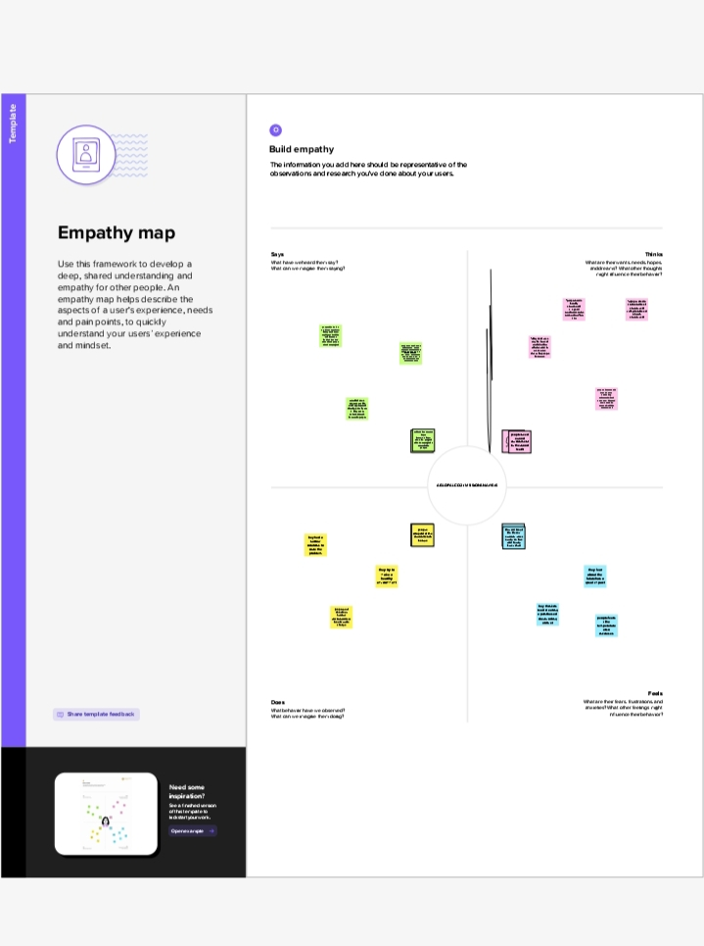

Ideation & Brainstroming Map:

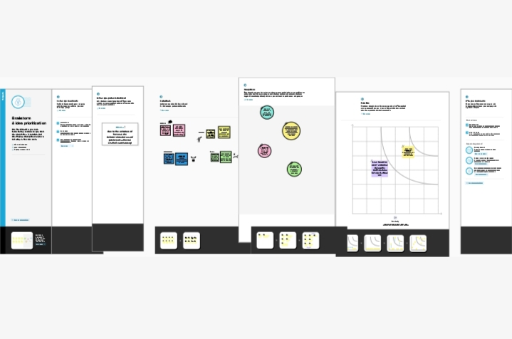

Result:

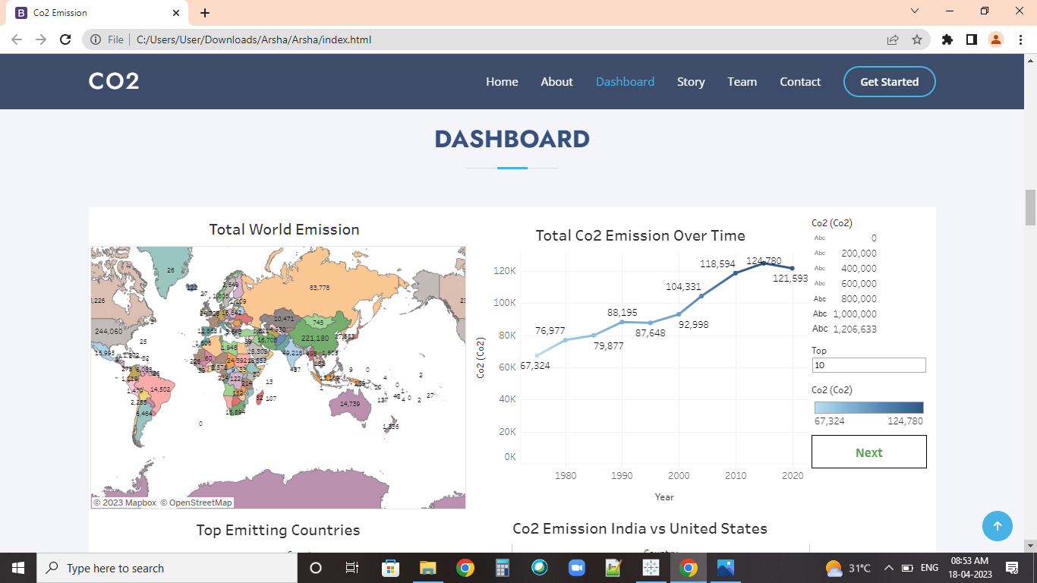

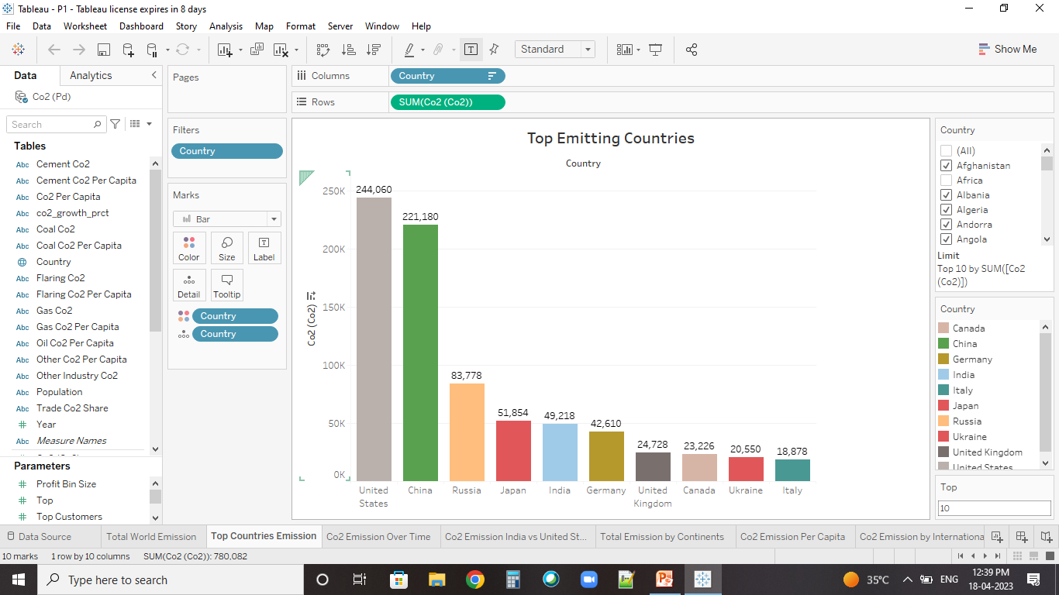

Advantages & Disadvantages:

* Improves the air quality
* Cleaner environment
* Benefits human health
* Helps to trap heat in our atmosphere
* Disrupting the earth’s climate
* Affecting the ocean temperature

Applications:

* Co2 is used to promoting the growth of plants in green houses
* Used for refrigeration and cooling

Conclusion:

Top emitting countries:

* United states is the highest co2 emiting country
* China is the second highest co2 emitting country
* India has the 5th place
* Italy is the lowest co2 emitting country

Co2 emission per capita:

* United states has the 1st place in co2 emission per capita
* Russia has the 2nd place
* Germant has the 3rd place
* India has the last place in co2 emission per capita

Co2 emission in 2020:

* China is the highest co2 emitting country in 2020
* United states is the second co2 emitting country in 2020
* India is the third co2 emitting country in 2020
* Italy is the lowest co2 emitting country in 2020

Total emission by contenents:

* Asia is the top co2 emitting continent
* Eurobe is the secont highest co2 emitting continent
* North America is the third highest co2 emitting continent
* Antartica is the lowest co2 emitting continent

FUTURE SCOPE:

CO2 emissions from energy combustion grew by around 1.3% or 423 Mt in 2022, while CO2 emissions from industrial processes declined by 102 Mt. Emissions growth in 2022 was below global GDP growth (+3.2%), reverting to a decades-long trend of decoupling emissions and economic growth that was broken in 2021. Meanwhile, improvements in CO2 intensity of energy use were slightly slower than the past decade’s (2012-2021) annual average.

There were divergent trends between regions and sectors. CO2 emissions grew in North America and Asia (excluding People’s Republic of China [“China” hereafter]), outweighing reductions from Europe and China. At a global level, CO2 emissions from power and transport (including international bunkers) grew by 261 Mt and 254 Mt, respectively, more than offsetting reductions from industry and buildings.